TEAM ID | MCA
PROJECT TITLE | Smartphone Usage, Digital Addiction& Well-Being Analytics
MAXIMUM MARKS | 5 marks

Dashboard Design
Creating an effective dashboard involves thoughtful design to ensure that the presented information is clear, relevant, and easily understandable for the intended audience. For the Smartphone Usage, Digital Addiction & Well-Being Analytics project, the dashboard presents smartphone usage, addiction, and well-being measures in an interactive and visually understandable format.
Activity 1: Interactive and visually appealing dashboards
The dashboard is designed using Power BI to present smartphone usage and digital well-being information through KPI cards, bar charts, donut/pie charts, slicers, and analytical visuals. The design focuses on the following principles:
- Clear and Intuitive Layout
- Appropriate Visualizations
- Colour and Theming
- Interactive Filters and Slicers
- Key Influencers
- Decomposition Tree
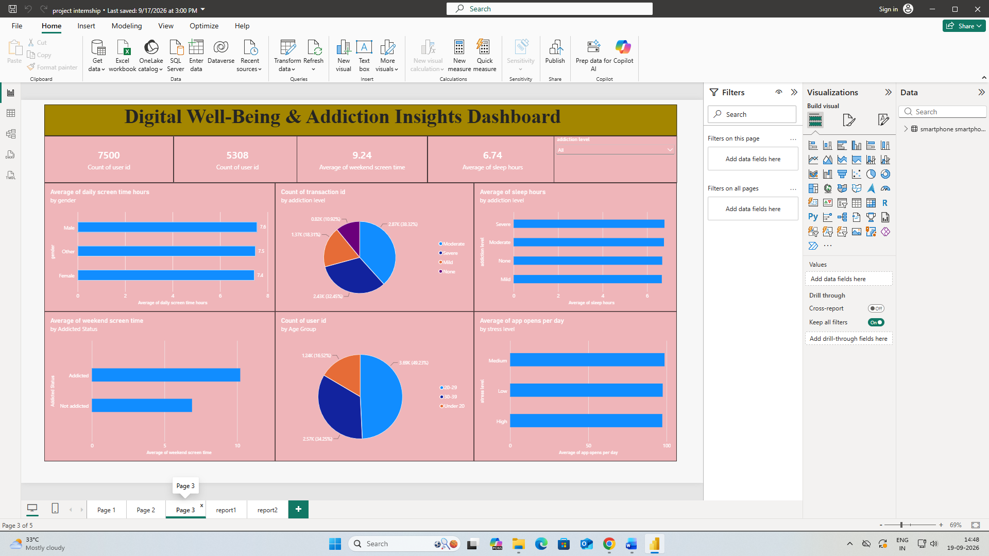
- Major Outcomes from the Smartphone Usage, Digital Addiction & Well-Being Dashboard:

- Total Users: The dashboard records 7,500 users, providing the overall user population analyzed in the project.

- Weekend Screen Time: The average weekend screen time is 9.24 hours, indicating substantial smartphone usage during weekends in the analyzed dataset.

- Sleep Duration: The overall average sleep duration shown on the dashboard is 6.74 hours.

- Addiction-Level Distribution: The dashboard shows 2.87K users in the Moderate addiction category (38.32%), 2.43K in Severe (32.45%), 1.37K in Mild (18.31%), and 0.82K in None (10.92%).

- Age-Group Distribution: The dashboard shows approximately 3.69K users aged 20–29 (49.23%), 2.57K aged 30–39 (34.29%), and 1.24K under 20 (16.53%).

- Screen Time by Gender: Average daily screen time is approximately 7.6 hours for Male, 7.5 hours for Other, and 7.4 hours for Female users.

- Weekend Screen Time by Addiction Status: The dashboard shows approximately 10.2 hours for Addicted users and approximately 7.0 hours for Not addicted users.

